Term 1 Newsletter
Saint Anne’s Primary

Dear Boys, Girls, Parents & Guardians,
Welcome back!!!. It is lovely to see the boys and girls at school after such a long time off. As aways the children all look so smart in their uniforms. I would like to thank your for your cooperation on the new arragements in place to keep the staff and the children. We will continue to keep you updated as new guidance becomes avaialble.
Lost property
The quantity of lost property we have in the school is growing by the day. A huge amount of time is spent by staff members looking for lost property. Could I please ask that all your child’s clothing and lunch boxes are labelled? Many of the children leave their belongings outside or in the dinner school. I totally appreciate the cost of these items so I would urge you to speak to your child to take responsibility for their own belongings.
After School Classes
Sadly at this time we are not able to offer any after school clubs due to the restrictions in place. As soon we are able to provide clubs we will let you know.
Gym Days
On these days your child must come to school wearing their gym kit. Please ensure your child is dressed appropriately for Gym outdoors. At this time the children are not able to get changed for P.E in school.
- Saint Anne’s tracksuit
- black/navy leggings/joggers
- blue hoody
- pale blue polo shirt/tshirt
- trainers

Class | Gym Days
P1a | Monday and Tuesday
P1b | Monday and Tuesday
P2a | Thursday and Friday
P2b | Monday and Thursday
P3a | Monday and Friday
P3b | Wednesday and Friday
P4a | Tuesday and Thursday
P4b | Tuesday and Thursday
P5a | Monday and Friday
P5b | Monday and Friday
P6a | Tuesday and Thursday
P6b | Tuesday and Thursday
P7a | Wednesday and Friday
P7b | Wednesday and Friday

.

Glasgow City Council have introduced the 'School Car Free Zone' pilot project which aims to address such issues by limiting traffic in the streets surrounding schools at key times, creating a predominantly car free zone. Saint Anne’s has been identified as one of the schools planned for a car free zone to improve road safety for our pupils outside our school.
We are aiming to create a safer, more pleasant environment for everyone around schools.
The scheme will promote active travel to school by walking and cycling, which in turn, will help to reduce congestion and pollution in the area.
The anticipated benefits of the scheme include:
- An increase in walking and cycling and active lifestyles for pupils and parents/carers
- A reduction in traffic speed, congestion and pollution around the school gates which will aid children and parents when accessing school
- Improvements in levels of childhood obesity
- Provide a tool to allow the Council to proactively respond to parking related concerns raised by parents and residents
The restrictions will mean that most vehicles, including those driven by parents and carers at these schools will not be able to drive into the roads covered by the restrictions to drop off or pick up children during the periods that the restriction is in force. The allocated time for Saint Anne’s is 08:30-09.15 and 14.30 and 15.15.
The picture below illustrates the affected area.

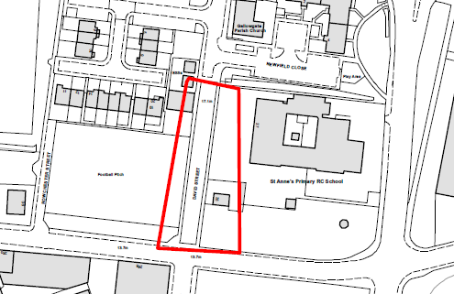

This signage will be displayed outside the school.
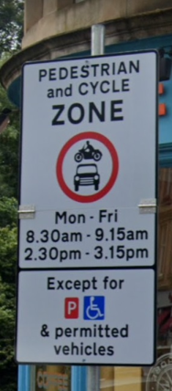

Important Dates for your Diary
School Term Dates 2020/21
September Weekend
- Friday 25 September 2020
- Monday 28 September 2020
October
- Friday 9 October 2020 (In-Service Day)
- Monday 12 to Friday 16 October 2020 (October Week)
December – Christmas and New Year
- Schools close at 2.30 pm on Tuesday 22 December 2020
- Wednesday 23 December 2020 to Tuesday 5 January 2021 (Christmas Holidays)

Updated school term dates 2021
January
- Schools return on Wednesday 6 January 2021
February Mid-term break
- Friday 5 February 2021
- Monday 8 February 2021
- Tuesday 9 February 2021
- Wednesday 10 February 2021 (In-service day)
April – Spring Holiday (Easter)
- School close at 2.30 pm on Thursday 1 April 2021
- Good Friday 2 April 2021
- Easter Monday 5 April 2021
- Schools return on Monday 19 April 2021
May
- Monday 3 May 2021 (May holiday)
- Thursday 6 May 2021 (In-Service day to coincide with Scottish Parliament Elections)
- Friday 28 May 2021 and Monday 31 May 2021 (May weekend)
June
- Schools Close at 1 pm on Thursday 24 June 2021
August
- Thursday 12 August 2021 (Return date for Teachers & In-Service Day)
- Friday 13 August 2021 (In-Service Day)
- Monday 16 August 2021 (Return date for the pupils)

Kind regards,
Mrs W Barr
Head Teacher

