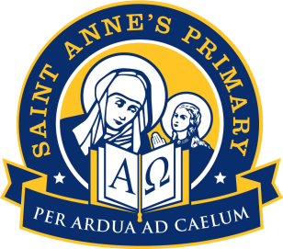

24th August 2020

Dear Parent/ Guardian,
VITAL INFORMATION ON FREE SCHOOL MEALS AND CLOTHING GRANT

During lockdown many of our families who hadn’t registered for Free School Meals missed out on £20 a week per child, meal vouchers. This would have amounted to hundreds of pounds if it had been completed at the beginning of the school year. Although Glasgow City Council provides free school meals for Primary 1-4, many of you will be unaware if you are entitled to this. You have to apply for this separately. This will also include breakfast club provision, should it be needed. As well as this you may also be entitled to a Clothing Grant. This can be as much as £190 per child. We strongly urge you to contact the school if you receive any of the following:
Eligible Benefits
- Housing Benefit/ Council Tax Reduction
- Income Support or Jobseekers Allowance – you will need a copy of your award letter dated within the past 3 months.
- Both Working Tax Credit and Child Tax Credit with a household income of £7330 or less – you will need a copy of your recent award letter showing your household income and detailing your children's names.
- Universal Credit with a monthly earned income of not more than £610- you will need a copy of your most recent statement or screen print showing your 'pay for the period'.
- Child Tax Credit only with an annual income of less than £16,105 – you will need a copy of your 2020/2021 child tax credit award letter detailing your child(ren)'s names and your annual income.
- Income related Employment and Support Allowance – you will need a copy of your award letter dated within the past 3 months.
- Asylum Seekers – you will need to show your ARC Card or BAIL201 Letter or Serco Occupancy Agreement

We would like to offer support to any family who thinks they may qualify for this. We can provide 1 to 1 online support to make an application as well as completing paper copies if this is more suitable. I strongly recommend that you contact the school to make an appointment to see myself and Kathryn Dool, our Family Support Worker.
If you would like to apply yourself online please use this link:
https://www.glasgow.gov.uk/article/17885/Clothing-Grants-and-Free-School-Meals
I look forward to hearing from you,
Kind Regards,
Mrs Wylie
DHT

